**RECRUITER INTERVIEW GUIDE:**

The Recruiter is the middle-man between the client that is looking to hire an Automation Tester and the future potential employee yourself. The goal of the Recruiter is to place a qualified candidate that

demonstrates great soft skills and technical skills. You will go through various types of recruiters: Direct, Prime, and sub-vendor. You will notice that a Direct recruiter will actually take the time and get to know

you more since the recruiter directly works for the company looking to hire so they are invested in you (GEICO is an example of direct recruitment). A prime recruiter will represent a vendor that has a direct

relationship with the client, in this case, the recruiter is still remaining selective because a good candidate means more business for the vendor company. And finally, you will meet sub-vendor recruiters you will have very strict negotiations and will seem fast-paced in their conversations. Sub-vendor recruiters are there for volume-based calls they want to reach as many candidates as they possibly can within a 24-hour period.

The point is that not every recruiter is the same and your goal should be to show the recruiter your ‘CONFIDENCE’. Recruiters should be treated with respect as they represent you in front of the

hiring manager and client. I have compiled common recruiter interview questions that can be asked. For your assignment please prepare individual responses for the following questions:

**Introduction:** Before the recruiter asks you any questions he/she will give you a reason for the call (we are looking for a candidate for a client …. Are you available?).

The recruiter will proceed to give you details about the Job description and requirements. Then they will verify whether you are comfortable with the requirements.

1. Hello, are you, currently in the market?

2. Can you tell me about yourself and what have you been doing in IT?

3. What are the tools that you are experienced with, what is the tool you would say you have been using recently in your project?

4. Where do you currently work and what is your current project?

5. What % of automation do you do?

6. Who is the end-client for the project? (They ask this to make sure they have no conflict of interest)

7. Why are you looking for a new opportunity?

8. What are your current salary requirements? (Remember: Salary for a senior QA contractor ranges from $40/hr to $60/hr, the average in the DC Area is $50/hr. I will suggest that most of you stick to 45-50 as the current salary, again depends on your confidence and negotiation skills. Asking for too much money is not always the best strategy since the recruiter needs room for his commission. The best way to deal with it is to ask the recruiter what his/her current budget is and then go on from there.)

9. What type of rate do you prefer and comfortable with W-2, 1099, or C2C?

10. Are you looking for a full-time or Contract opportunity?

11. Do you know the following tools (this list depends on the job description such as UFT, Oracle, SVN, Jenkins, and ALM)?

12. If the client presents an offer to you how long do you need before coming on board?

13. Do you have any questions for me?

**Java**

**1.** **What is the difference between break, continue, and return statements?**

The keywords break and continue are a part of the control structures in Java.

* The break statement results in the termination of the loop, it will come out of the loop and stops further iterations. It is also used in switch case-control.
* Continue statement is mostly used inside loops. Whenever it is encountered inside a loop, control directly jumps to the beginning of the loop for the next iteration, skipping the execution of statements inside the loop’s body for the current iteration.
* The return statement takes you out of the method. It stops executing the method and returns from themethod execution.

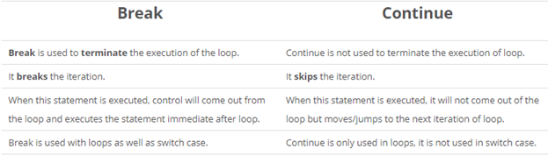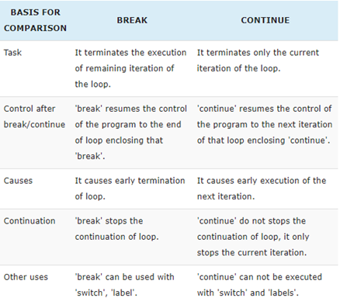

**2.** **Static and dynamic polymorphism?**

Polymorphism in java is a concept by which we can perform a single action by different ways. Polymorphism is derived from 2 greek words: poly and morphs. The word "poly" means many and "morphs" means forms. So, polymorphism means many forms.

There are two types of polymorphism in java: compile-time(static) polymorphism and runtime(dynamic) polymorphism. We can perform polymorphism in java by method overloading and method overriding.

* Static (compile-time)
* Static polymorphism in Java is achieved by method overloading. Method overloading means there are several methods present in a class having the same name but different types/order/number of parameters.
* The compiler looks at the method signature and decides which method to invoke for a particular method call at compile time. So, this is called compile-time polymorphism or static binding.
* Dynamic(runtime)
* Dynamic polymorphism in Java is achieved by method overriding. So, when a call to some method is made, Java waits until runtime to determine which object is actually being pointed to by the reference.

**Selenium**

1. **Explain what are the JUnits annotation linked with Selenium?**

The JUnits annotation linked with Selenium are

* @Before public void method() – It will perform the method () before each test, this method can prepare the test
* @Test public void method() – Annotations @Test identifies that this method is a test method environment
* @After public void method()- To execute a method before this annotation is used, the test method must start with test@Before

1. **Explain what is Data-driven framework and Keyword driven?**

* **Data-driven framework**:  In this framework, the test data is separated and kept outside the Test Scripts, while test case logic resides in Test Scripts.  Test data is read from the external files ( Excel Files) and are loaded into the variables inside the Test Script.  Variables are used for both for input values and for verification values.
* **Keyword-driven framework**: The keyword driven frameworks requires the development of data tables and keywords, independent of the test automation.  In a keyword-driven test, the functionality of the application under test is documented in a table as well as step by step instructions for each test.

1. **Mention 5 different exceptions you had in Selenium web driver?**

The 5 different exceptions you had in Selenium web drivers are

* WebDriverException
* NoAlertPresentException
* NoSuchWindowException
* NoSuchElementException
* TimeoutException

1. **How can we handle web-based pop-up?**

WebDriver offers the users a very efficient way to [handle these pop-ups using the Alert interface](http://www.softwaretestinghelp.com/handle-alerts-popups-selenium-webdriver-selenium-tutorial-16/). There are four methods that we would be using along with the Alert interface.

* void dismiss() – The accept() method clicks on the “Cancel” button as soon as the pop-up window appears.
* void accept() – The accept() method clicks on the “Ok” button as soon as the pop-up window appears.
* String getText() – The getText() method returns the text displayed on the alert box.
* void sendKeys(String stringToSend) – The sendKeys() method enters the specified string pattern into the alert box.

**Syntax:**  
*// accepting javascript alert*  
*Alert alert = driver.switchTo().alert();*  
*alert.accept();*

1. **How can we handle windows based pop up?**

Selenium is an automation testing tool that supports only web application testing, which means, it doesn’t support testing of windows based applications. However Selenium alone can’t help the situation but along with some third party intervention, this problem can be overcome. There are several third-party tools available for handling window-based pop-ups along with the selenium like AutoIT, Robot class, etc.

# 

# 

# 

# Real Interview Questions

1. Describe a situation in which you were able to use persuasion to successfully convince someone to see things your way.
2. Describe a time when you were faced with a stressful situation that demonstrated your coping skills.
3. Give me a specific example of a time when you used good judgment and logic in solving a problem.
4. Give me an example of a time when you set a goal and were able to meet or achieve it.
5. Give me a specific example of a time when you had to confront a policy with which you did not agree.
6. What is your typical way of dealing with conflict? Give me an example.
7. Tell me about a difficult decision you've made in the last year.
8. Give me an example of a time when something you tried to accomplish and failed.
9. Give me an example of when you showed initiative and took the lead.
10. Give me an example of a time when you motivated others.